1
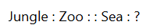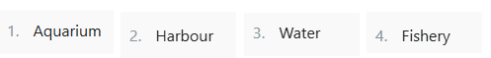
2 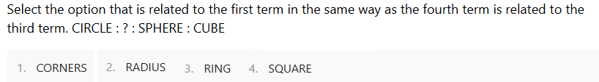
3.
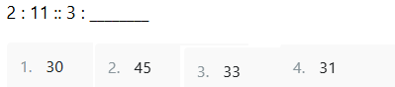
4.
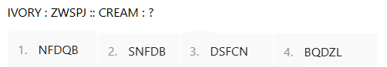
5.
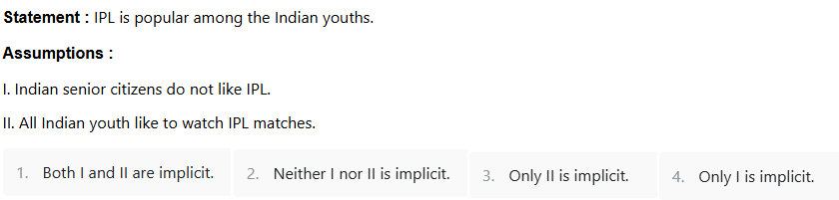
6.
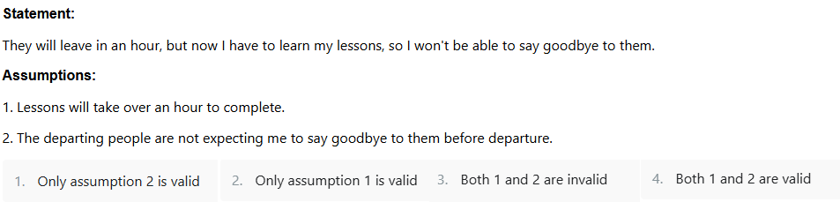
7
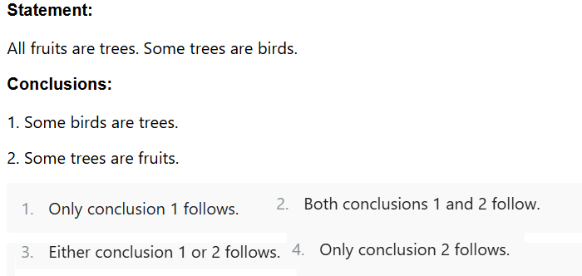
8
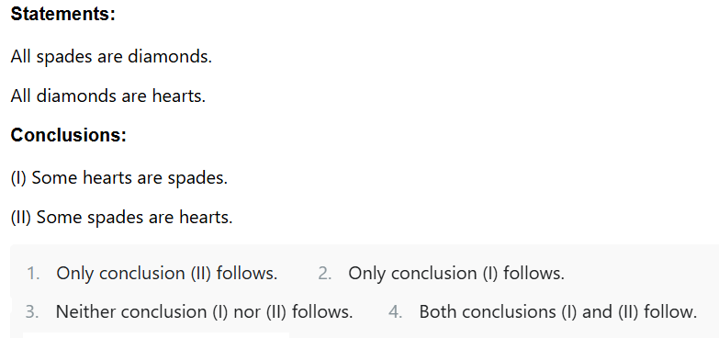
9
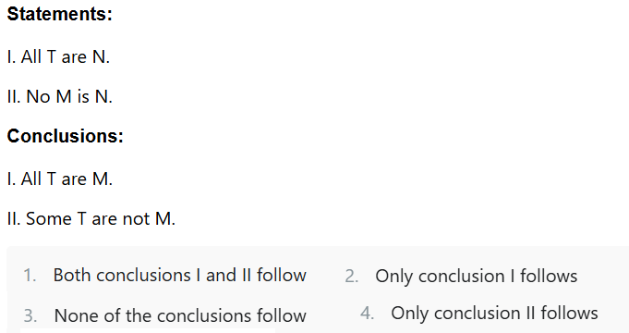
10.
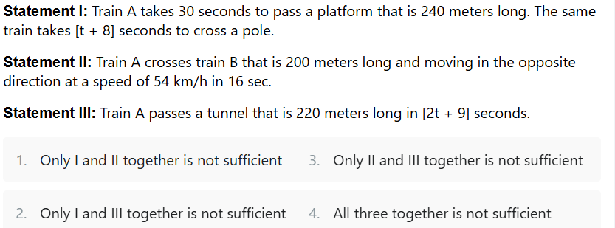
11.
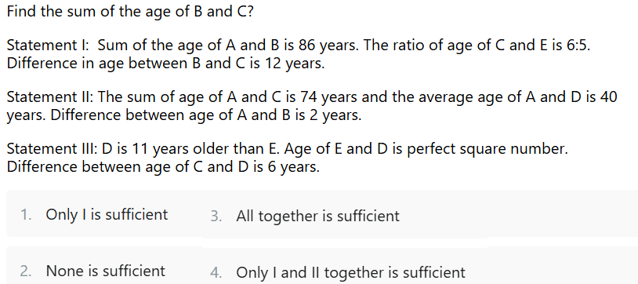
12.
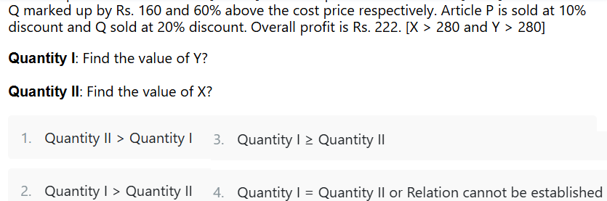
13
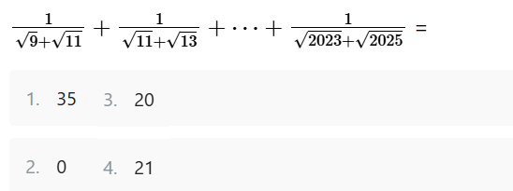
14.
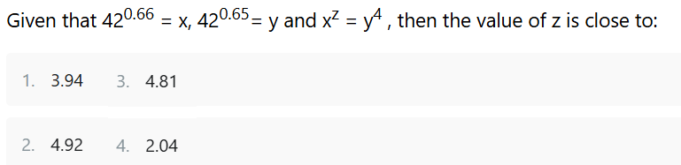
15
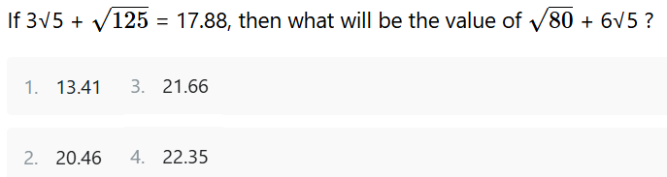
16
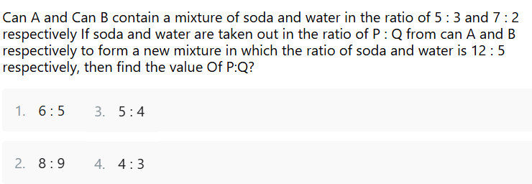
17
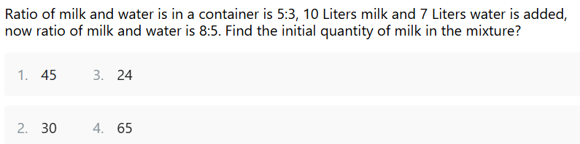
18
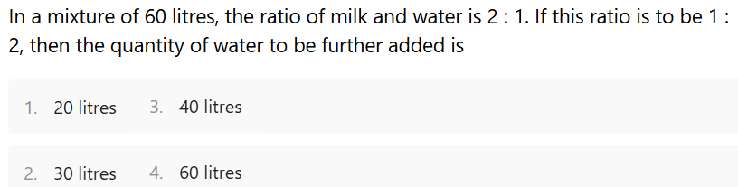
19
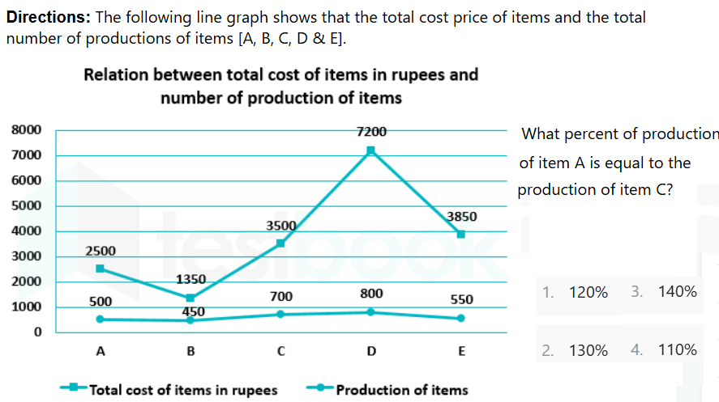
20
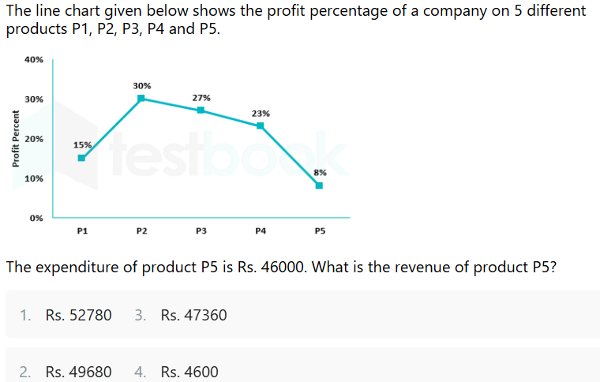
21
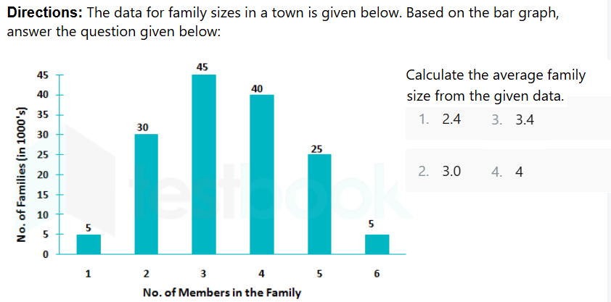
22
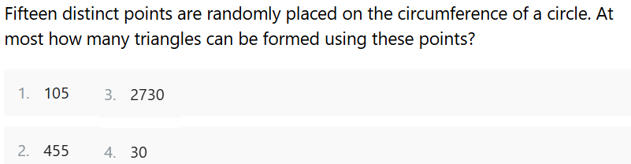
23
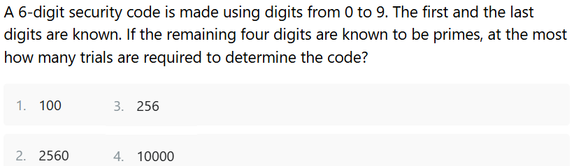
24
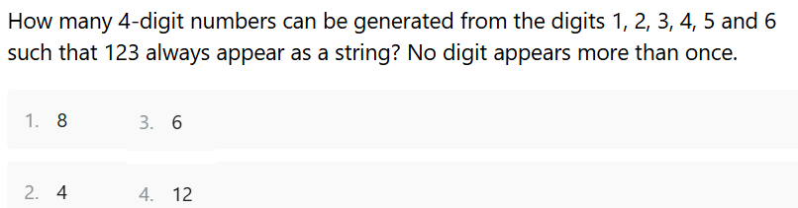
25.
WAP to write a Generic Method to Sort Elements in an Array

TC1
I/P ["A", "B", "C"]
O/P ["C", "B", "A"]

TC2
I/P [1, 2, 3, 4]
O/P [1, 4, 3, 2]

26.
WAP with a function named "enough" that takes one integer argument, call it "goal" and returns as its value the smallest positive integer n for which 1+2+3+. . . +n is at least equal to goal .

TC1
System.out.println(enough(9));
/ /will print 4 because 1+2+3+4 ≥ 9 // but 1+2+3<9
27.
WAP to find Intersection of Two Lists
TC1
I/P
[1, 2, 3, 4, 5]

[4, 5, 6, 7, 8]
O/P

[4, 5]

Answers:-
1)1
2)4
3)1
4)2
5)2
6)2
7)2
8)4
9)4
10)4
11)3
12)2
13)4
14)1
15)4
16)2
17)2
18)4
19)3
20)2
21)3
22)2
23)3
24)3
25)
26)
27)
28)
29)
30)

